**About Us**

The North Texas Regional Institutional Review Board (NTR IRB) is a partnership of institutions in North Texas, which provides affiliated investigators with human subject research protection review services... within a single IRB framework!

The NTR IRB reviews research including but not limited to: hospital and university based clinical research, residency projects, biomedical and social- behavioral studies.

The NTR IRB is committed to driving life-enhancing research, ensuring all reviewed research at affiliated institutions complies with federal regulations and are ethically and scientifically sound.

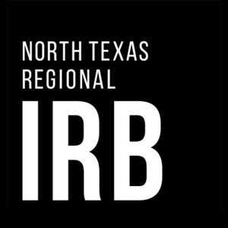**Connect with us:**



**+817-735-0409**

[**NorthTexRegIRB@unthsc.edu**](mailto:NorthTexRegIRB@unthsc.edu)

**https://**[**www.unthsc.edu/north**](http://www.unthsc.edu/north)

**-texas-regional-irb/**



**North Texas Regional**

**Institutional Review Board**





# What are the benefits of having a Regional IRB?

**Overall, having a regional IRB simplifies the IRB review process! Examples of specific benefits to affiliated investigators include:**

**Collaboration: Increase your opportunities for human subject research collaborations across the North Texas area with a built-in network.**

**Efficiency: Enjoy a streamlined IRB review process with decreased administrative burden on investigators.**

**Resources: With one centralized office and board, we can provide you with high quality resources, guidance, and training.**

**“Having a regional IRB has been a tremendous help for improving efficiency and decreasing time spent on regulatory processes! It is not only easier to collaborate between our two institutions, but it is also easier to collaborate on projects that include additional institutions.”**

***- NTR IRB-affiliated Principal Investigator***

**NTR IRB:**

**Mission, Vision, Purpose**

## Mission

**Promote and support medical research conducted in North Texas.**

## Vision

**One IRB creating collaborative partnerships and motivating research across Texas.**

## Purpose

**To facilitate life- enhancing research across North Texas.**

# How can you become a partner?

**There are several ways an institution can be part of the North Texas Regional IRB:**

***Larger institutions (universities, hospitals, health care systems, etc.) may wish to become a full participating member.***

***Others may want to become involved on a project-by-project contractual basis.***

***Some institutions may need a tailored approach, based on their needs.***

**Contact the NTR IRB office for specific details and to discuss how your organization might become part of the North Texas Regional IRB (see back for ways to contact us).**